Tail dependence: EURUSD and NZDUSD
Method 19 / daily log returns / alpha=0.05 / Alpari D1 full available history

Study setup
Logical pair: EURUSD , NZDUSD
Broker symbols: EURUSD_i , NZDUSD_i
Snapshot: 2026-11-03_majors_alpari_D1
Timeframe: D1
Matched return window: 1999-01-05 to 2026-11-02 (UTC bar dates)
Matched return count n: 7186
Dropped unfinished last bar dated 2026-11-03 UTC after a tick-volume check against the prior complete day.
Uniforms: ranks/(n+1); alpha=0.05
Complete matched rows (Excel): EURUSD-NZDUSD_Tail_D1.xlsx
Complete matched rows (HTML table): EURUSD-NZDUSD_Tail_D1_data.html

Method carried forward
Tail dependence counts how often both legs sit in an extreme uniform tail together. Matched daily log returns of close, ln(close_t / close_t-1), become u_i = rank(x_i)/(n+1) and v_i = rank(y_i)/(n+1). At alpha=0.05, lower L_hat = (# u<=alpha and v<=alpha) / (# conditioning leg <= alpha); upper uses >= 1-alpha. Both conditioning directions are reported with numerator and denominator counts. Quotes are not inverted. L_hat(0.05) is a finite-sample frequency, not the asymptotic lambda. Same-sample Pearson r is a side check. This is not causation and not a trading signal.

Results
tail | cond | L_hat | num | denom
lower | NZDUSD | 0.306407 | 110 | 359
lower | EURUSD | 0.306407 | 110 | 359
upper | NZDUSD | 0.331476 | 119 | 359
upper | EURUSD | 0.331476 | 119 | 359
Pearson r on returns: 0.549808

Conclusion
Over 7186 matched daily rows for EURUSD and NZDUSD at alpha=0.05, lower L_hat conditioning on NZDUSD is 0.3064 (110/359); conditioning on EURUSD is 0.3064. Upper L_hat conditioning on NZDUSD is 0.3315; on EURUSD is 0.3315. Pearson r = 0.5498. These are finite-sample frequencies, not asymptotic lambda and not a trading signal.

Charts
Daily closes

Daily log returns

Uniforms with alpha lines
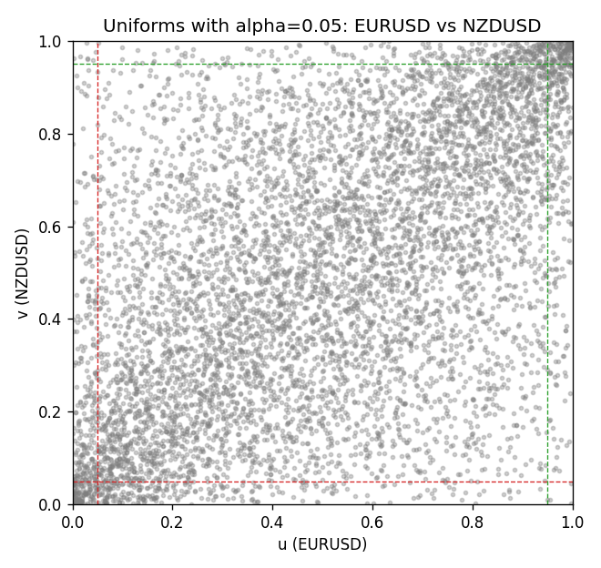

Data report
Every matched row is stored in the sibling Excel workbook named EURUSD-NZDUSD_Tail_D1.xlsx, including u and v. Embedding all rows as a Word table is impractical; this file holds column summaries and the first and last 15 matched rows.
Columns: time, EURUSD_open, NZDUSD_open, EURUSD_high, NZDUSD_high, EURUSD_low, NZDUSD_low, EURUSD_close, NZDUSD_close, EURUSD_tick_volume, NZDUSD_tick_volume, EURUSD_spread, NZDUSD_spread, EURUSD_real_volume, NZDUSD_real_volume, EURUSD_log_return, NZDUSD_log_return, u, v
Column summaries (matched calculation rows)
column | count | mean | std | min | 25% | 50% | 75% | max
EURUSD_open | 7186 | 1.181357 | 0.15085833 | 0.8272 | 1.086165 | 1.16609 | 1.2939475 | 1.5995
NZDUSD_open | 7186 | 0.65641776 | 0.10819833 | 0.3913 | 0.59134 | 0.6684 | 0.7249075 | 0.88218
EURUSD_high | 7186 | 1.1864878 | 0.15145386 | 0.8326 | 1.09024 | 1.17121 | 1.2993075 | 1.6038
NZDUSD_high | 7186 | 0.66033433 | 0.10869188 | 0.3961 | 0.59475 | 0.67202 | 0.72936 | 0.88421
EURUSD_low | 7186 | 1.1763494 | 0.15017707 | 0.8227 | 1.082045 | 1.162475 | 1.2884175 | 1.5865
NZDUSD_low | 7186 | 0.65273031 | 0.10779283 | 0.3897 | 0.5880725 | 0.664185 | 0.720965 | 0.87988
EURUSD_close | 7186 | 1.1813978 | 0.15082738 | 0.8267 | 1.0860425 | 1.16602 | 1.2939725 | 1.5997
NZDUSD_close | 7186 | 0.65649194 | 0.10819527 | 0.3907 | 0.59159 | 0.66842 | 0.725015 | 0.8822
EURUSD_tick_volume | 7186 | 103205.25 | 173535.32 | 218 | 9413.25 | 52774.5 | 99579.75 | 1471626
NZDUSD_tick_volume | 7186 | 68709.014 | 123134.25 | 16 | 5585.5 | 33893.5 | 58510.5 | 1127682
EURUSD_spread | 7186 | 19.350682 | 16.562781 | 0 | 8 | 12 | 27.5 | 50
NZDUSD_spread | 7186 | 30.284303 | 25.649992 | 0 | 9 | 17 | 47.5 | 80
EURUSD_real_volume | 7186 | 4.0330482e+10 | 1.6691688e+11 | 0 | 0 | 0 | 0 | 3.6149665e+12
NZDUSD_real_volume | 7186 | 1.6701379e+10 | 8.497804e+10 | 0 | 0 | 0 | 0 | 2.705649e+12
EURUSD_log_return | 7186 | -4.99e-06 | 0.00579654 | -0.03123819 | -0.00323792 | 0 | 0.00325328 | 0.03433183
NZDUSD_log_return | 7186 | 9.3e-06 | 0.0076423 | -0.07027433 | -0.00425367 | 0.00022883 | 0.00457975 | 0.05966839
u | 7186 | 0.5 | 0.28865505 | 0.00013914 | 0.25006957 | 0.49951301 | 0.74993043 | 0.99986086
v | 7186 | 0.5 | 0.28865504 | 0.00013914 | 0.25006957 | 0.5 | 0.74993043 | 0.99986086
First 15 matched rows (selected columns)
time | EURUSD_log_return | NZDUSD_log_return | u | v
1999-01-05 | -0.0048360507 | -0.0018597736 | 0.16877696 | 0.37352164
1999-01-06 | -0.011547966 | 0.0020455609 | 0.028106303 | 0.61458188
1999-01-07 | 0.0076280636 | 0.0062963171 | 0.91943787 | 0.82663142
1999-01-08 | -0.010902799 | -0.00055396548 | 0.032558787 | 0.45164881
1999-01-11 | -0.007103287 | 0.010290425 | 0.096006679 | 0.93001252
1999-01-12 | 0.0045103728 | -0.0053157489 | 0.81953527 | 0.20592737
1999-01-13 | 0.010845346 | -0.0099742238 | 0.96660637 | 0.079309865
1999-01-14 | 0 | -0.00018564931 | 0.49951301 | 0.47516349
1999-01-15 | -0.010153245 | -0.00074294208 | 0.039794073 | 0.44093502
1999-01-18 | 0.0036256946 | -0.0018597736 | 0.77473216 | 0.37352164
1999-01-19 | -0.00017235436 | 0.0018597736 | 0.48434674 | 0.60358981
1999-01-20 | -0.0031939256 | 0.0040793678 | 0.25323501 | 0.72568527
1999-01-21 | 0.0030215416 | 0.0040627941 | 0.73591206 | 0.72450257
1999-01-22 | -0.0012075213 | -0.012051689 | 0.39307082 | 0.052873243
1999-01-25 | -0.0030251979 | -0.0035504102 | 0.26297482 | 0.28648949
Last 15 matched rows (selected columns)
time | EURUSD_log_return | NZDUSD_log_return | u | v
2026-10-13 | 0.0037402957 | 0.0047326165 | 0.7818283 | 0.75803534
2026-10-14 | -0.0037582255 | -0.0037306483 | 0.2237373 | 0.27730625
2026-10-15 | 0.0056053107 | 0.0047634855 | 0.86572979 | 0.75956588
2026-10-16 | 0.0017724895 | 0.0057501001 | 0.65006261 | 0.80562126
2026-10-19 | -0.0025394633 | 0.0018917133 | 0.29595102 | 0.60637262
2026-10-20 | 0.0023881672 | 0.0037199341 | 0.69361347 | 0.7065535
2026-10-21 | -0.00032046717 | 0.0030923331 | 0.47140671 | 0.67524697
2026-10-22 | -0.0015949606 | -0.0033035227 | 0.36357312 | 0.29609016
2026-10-23 | -0.001338521 | 0.0030929853 | 0.38263531 | 0.67538611
2026-10-26 | -0.0022706559 | -0.0028993932 | 0.31292612 | 0.3166829
2026-10-27 | -0.004152342 | -0.00026399852 | 0.2005009 | 0.46876304
2026-10-28 | 0.0022262927 | -0.0097283914 | 0.68345624 | 0.084318909
2026-10-29 | 0.0022571351 | 0.00062190714 | 0.6860999 | 0.52594963
2026-10-30 | -0.0011458446 | 0.00019537668 | 0.39835815 | 0.49839989
2026-11-02 | 0.002120569 | -0.0025962955 | 0.6770558 | 0.33198831

